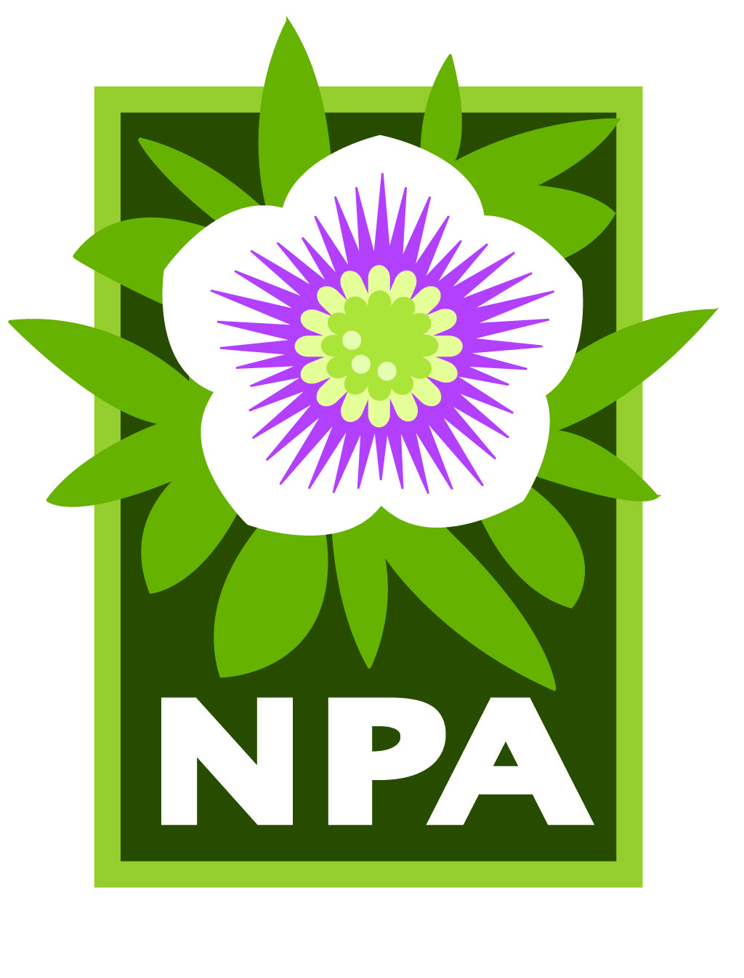

**NPA Business Membership**

Now you can reach more than 1,500 avid gardeners year round with a **Business Membership** with the Northwest Perennial Alliance (NPA). The annual membership fee is $80. Your business will be featured in NPA’s popular Open Gardens Directory, a book that our members refer to again and again throughout the year. To be listed in the 2019 edition, you must register by March 15, 2019.

**Benefits of NPA Business Membership**

1. As a member, your business will be published in the “Business Spotlight”section of the Open Gardens Directory and the NPA website. Your listing will include your business name, owner’s name, contact information, location, hours, a description of your business, any discounts you offer to NPA members, and a link to your website.

2. If you choose to offer a minimum 10% discount to NPA members, your business will be specially highlighted in the NPA Open Gardens Directory and will be listed on the “Businesses Offering a Discount” page on the NPA website. This page lists your business name, location, contact information, website, hours and discount offer. Our members seek out and support business that offer discounts to NPA members.

3. If you have a display garden that you want to open, your business will also be published in NPA’s Open Gardens Directory in the Open Gardens tour section. You may have the garden open on specific tour dates, listed by appointment only, or listed under the “Public and Display Gardens” section (for gardens that are open on a regular schedule).

**Join or renew your membership by March 15, 2019.** Don’t miss this opportunity! Register now by visiting the NPA website at [northwestperennialalliance.org](http://www.northwestperennialalliance.org/). Click on “Join or Renew” and select Business Membership. You must also complete and submit the Business Membership registration form available on the “Join or Renew” page.

*Note: Registrations received after March 15 will not be included in the 2019 Directory, but will be listed on our website. The annual membership fee will increase to $85 on March 16, 2019.*

**About us**. Founded in 1984, NPA is one of the largest nonprofit gardening organizations in Washington, with members throughout the Puget Sound area. In addition to our successful Open Gardens program, we offer lectures, classes, a seed exchange, plant sales and a wide network of garden clubs called neighborhood groups. NPA also partners with the Bellevue Botanical Garden, where our volunteers built and maintain the famous NPA Border.

Northwest Perennial Alliance PO Box 1034, Bellevue, WA 98009 425-647-6004

[www.northwestperennialalliance.org](http://www.northwestperennialalliance.org) NPA is a registered 501(c)(3) non-profit organization